Marketing Plan



Submitted by: Charlie Evert, Danielle Kelly, and John Diamond

Submitted to: Dr. David Allan

Date Submitted: July 15, 2021

Executive Summary

This marketing plan is presented for Philly Pawsabilities, a 501c(3) companion animal rescue located in Philadelphia, Pennsylvania.

**Mission**

Philly Pawsabilities is dedicated to saving the lives of homeless companion animals. We promise to provide care and protection for the animals. Philly Pawsabilities advocates for animal welfare through adoption, fostering, education, and resources for the animals and people.

**Vision**

To create a world where all adoptable companion animals find homes, therefore eliminating the euthanasia of these animals.

**Organizational Goals**

* Save and rehabilitate (if necessary) 300 or more companion animals per year and place them in loving and safe homes
* Obtain at least 30 fosters for 2022-2023. Maintain this number of fosters and look to add five or more fosters every year thereafter
* Host at least one to two fundraising events per quarter
* Educate at least 5,000 Philadelphia residents annually on animal welfare through presentations at schools, places of worship/religious events, and prisons
* Strengthen relationship with high kill shelters in the southern states in the United States (U.S.) where breed restriction laws are much more prevalent, and save at least 50 dogs per year from southern United States (U.S.) shelters

**2021 Internal Analysis Summary**

* Strengths- Dedicated staff and volunteers looking to make an immediate impact in animal rescue in Philadelphia, strong relationships with two local companion animal rescues who are mentoring the founders of Philly Pawsabilities
* Weaknesses- Currently no facilities to house animals, lack of inhouse trainer to train dogs before being adopted, not as many fosters/volunteers as other established rescues in Philadelphia and the surrounding area
* Nationwide, companion animals were being adopted during the COVID-19 pandemic. As of March 2021, owner surrenders are up 80%, meaning animals are being returned to the shelters. (NBC Boston).

**Key Marketing Objectives**

* Build social media presence through targeted ads and aim to obtain 10,000 or more followers on each platform: Facebook, Instagram, Twitter, and YouTube
* Promote the fundraising and animal welfare education event “Yappy Hour with Philly Pawsabilities” to raise $5,000
* Increase number of adoptions by 5% by obtaining more social media followers and fundraiser event
* Increase number of volunteers by 3% by obtaining more social media followers and fundraiser event
* Increase annual adoptions by 5% by obtaining more social media followers and fundraiser event

# Table of Contents

**Table of Contents 4**

**Introduction 5**

**Situational Analysis 5**

**Political / Legal 5**

**Technological 5**

**Bargaining Power 6**

**Structure 6**

**Culture 6**

**Resources 6**

**Competitive Environment** **6**

**SWOT 7**

**Strengths 7**

**Weaknesses 7**

**Opportunities 7**

**Threats 7**

**Sociocultural 7**

**Economic 8**

**Marketing Research 8**

**Marketing Goals and Objectives 9**

**Goals 9**

**Objectives 9**

**Strategies 10**

**Market Strategies 10**

**Segmentation 10**

**Target Marketing 10**

**Positioning 10**

**Pricing 10**

**Implementation 10**

**Marketing Control and Metrics 11**

**Contingency Planning 12**

**Financial Analysis** 12

# Introduction

Philly Pawsabilities is a 501c(3) companion animal rescue located in Philadelphia, Pennsylvania. The organization was founded in 2021 after the three founders of Philly Pawsabilities (Charlie Evert, Danielle Kelly, and John Diamond) read a report that just under 1,700 cats and dogs were euthanized *(*ACCT Philly**)***.* The co-founders had two goals in mind; save as many animals as possible, and educate the residents of Philadelphia on animal welfare.

In this marketing plan, we provide a high level overview of Philly Pawsabilities and the goals for the rescue. The remainder of the plan will detail the implementation plan, financial analysis, and key objectives for 2022-2023.

# Situational Analysis

## **Political / Legal**

With 10 states currently implementing breed restriction laws, Pennsylvania legislation could decide to adopt similar restrictions on certain breeds of animals. Such restrictions could make fostering and adopting restricted breeds difficult within the surrounding area.

Also, support from local government agencies is integral to the success of Philly Pawsabilities. By working with local animal control agencies, Philly Pawsabilities can increase survival rates by intervening with applicable cases. Lastly, local governments can provide funding through grants to help cover operating costs. (Cheatsheet.com).

## **Technological**

Philly Pawsabilities will have a strong social media presence to raise awareness for the organization, educate the public, recruit volunteers, and communicate with other rescues within the area. These online platforms will also be used to promote and highlight animals for adoption and provide the public with helpful tips and information. As the business continues to grow, and public needs evolve, Philly Pawsabilities can use these platforms to tailor its messaging to meet the changing environment.

## **Bargaining Power**

Philly Pawsabilities will be situated in areas where animal rescues are sparse, providing considerable bargaining power with its customers. Since Philly Pawsabilities will be the closest animal rescue in the area for its customer base, their lack of alternative options will be a strength, and demand will hopefully remain consistently high in these areas.

## **Structure**

Philly Pawsabilities is a nonprofit organization managed by Charlie Evert, Danielle Kelly, and John Diamond. The organization is also staffed with 10 full time volunteers and an additional 10 part-time volunteers. Charlie Evert manages the budgeting and financial report of the operations. Danielle Kelly oversees the marketing platforms, organizes fundraising events and promotions, and manages social media. John Diamond manages the staff and handles the day to day operations. Funding for Philly Pawsabilities is obtained through government grants, adoption fees, and donations.

## **Culture**

At Philly Pawsabilities, animals come first. The entire staff shares the same love and passion for animals, which is why the organization is committed to rescue every animal that comes through their doors. Such a commitment is met by an innovative and motivated staff, utilizing technology to communicate with customers and surrounding rescues to find forever homes for every animal.

## **Resources**

### ***Marketing***

Philly Pawsabilities marketing efforts will be led by Danielle Kelly, who has three years’ experience working in animal rescues. Her experience, along with her strong ties to the community provide a great foundation for the organization's marketing platform. Danielle will have a team of three college interns, all with strong backgrounds in various social media platforms.

### ***Financial***

Philly Pawsabilities will operate as a nonprofit organization, relying on initial funding from fundraisers, crowdfunding (GoFundMe), online donations, and government grants. Revenue will be generated throughout the year through adoption fees which are structured by animal and age.

### ***Operations***

Philly Pawsabilities will open its first rescue location in North Philadelphia, a location that does not currently have a rescue within a five mile radius. Within the first year, the organization should have the resources and capacity to fulfill the needs of the North Philadelphia market. If successful, within the next two to three years we plan to expand into South and West Philadelphia.

### ***Staffing***

Within the first week of operations, Philly Pawsabilites will have nearly 25 staff members; three managers, ten full time staff members, ten part-time volunteers, and three interns. Each staff member will share a similar passion in rescuing animals. Staff members will be from the surrounding area, who are invested in giving back to their community.

**Competitive Environment**

**Bargaining Power of Buyers**

*High*- There are many companion animal rescues located in Philadelphia alone, not even including the companion animal rescues located in the Philadelphia suburbs. The buyer has many rescues, and breeders, to choose from when choosing a companion animal. Therefore they are very price sensitive, hence our prices will be in line with our competitors.

**Bargaining Power of Suppliers**

*High*- One reason for the abundance of homeless animals is that animals are not neutered/spayed. The more animals we have that are not neutered/spayed, the more animals that end up homeless and in Philadelphia’s only open admission shelter, Animal Care & Control Team of Philadelphia (ACCT Philly). The more animals that end up in ACCT, the more animal rescues that are needed. Thus, supplier relationships must be carefully cultivated, and any price necessary must be paid to save animal lives.

**Threat of New Entrants**

*High*- The threat of new entrants in the companion animal rescue space is high. ACCT Philly has garnered attention surrounding its leadership and misappropriation of funds (PhillyMag). The city of Philadelphia has also been under pressure for underfunding the city’s only open admission shelter in comparison to other comparable cities (PhillyMag.com). Many animal rights activists and animal lovers may decide to take a stand and save more animals, just like the founders of Philly Pawsabilities. However, the threat of new entrants is not negative, it is actually encouraged since it will reduce the amount of animals needing to be euthanized due to lack of space.

**Threat of Substitute Products or Services**

*Low to Moderate*- Although there is no threat to animal rescues, animals could be saved directly by an individual without going through an animal rescue. Individuals can directly adopt or foster animals through ACCT Philly (ACCTPhilly). As stated above, this is not a negative threat to substituting an animal rescue, as ultimately an animal is getting saved. Collaboration is key in solving our nonprofit’s goals.

**Rivalry Among Existing Competitors**

*Moderate to High*- Philadelphia and the surrounding suburbs has many companion animal rescues. However, when it comes to rescuing homeless animals, especially in Philadelphia, there can never be enough animal rescues. As of June 30th, 2021, there were currently 115 cats and 88 dogs available for adoption at ACCT Philly alone (ACCTPhilly). Rivalry is encouraged in the animal rescue space.

**SWOT**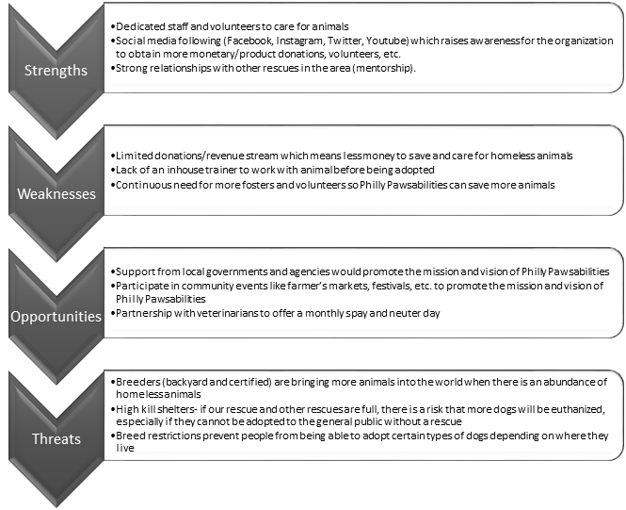

## **Sociocultural**

With the growing rise of animal rights awareness throughout the country, animal rescues such as Philly Pawsabilities are in a unique situation where they can capitalize on opportunity, while also giving back to the community. The topic of animal cruelty and abuse has been in the public spotlight for some time now. It has gained so much traction that in 2019 the Preventing Animal Cruelty and Torture (PACT) act was signed into law, making animal abuse a federal crime. Philly Pawsabilities offers the community an easy means to surrender an animal should the situation arise and has the resources to intervene where abuse is suspected. (CBSNews).

## **Economic**

During the height of the pandemic animal shelters and rescues across the country saw a 30-40% increase in adoptions. The primary reasons were to entertain families when lockdown restrictions were in place, and as emotional support animals during the uncertain times. Researchers are predicting a height in animal surrenders as restrictions continue to be lifted, and the country transitions closer to normal. As this trend begins to unfold Philly Pawsabilities will have the capacity and resources to take in any surrendered animals within the area.

A high surrender rate can make or break Philly Pawsabilities operations. Effectively managed, surrendered animals can be relocated, generating adoption fee revenue and freeing space for more displaced animals. Ineffective management would lead to overpopulation, putting the rescue in a situation where they would have to turn away new animals. (Washington Post).

# Marketing Research

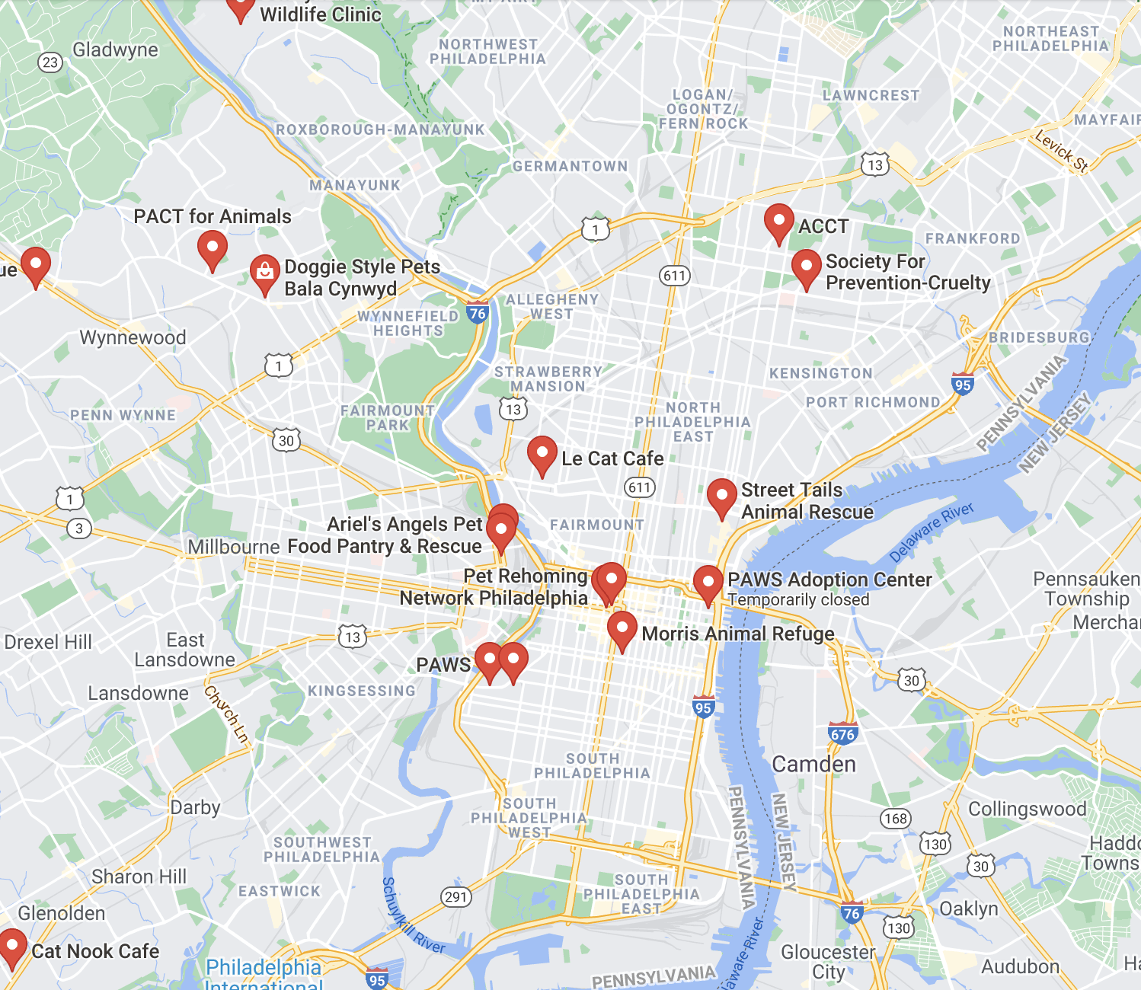

We gathered secondary data from both ACCT Philly as well as from Google Maps. Above is a Google Maps search for animal rescues in Philadelphia. North, West and South Philadelphia have significantly less animal rescues than Center City or the Main Line. (Google Maps).

The live-release rate has remained the same for the past 3 years, hovering around 89-93%. This means that for every 9 animals able to be rehomed, 1 has to be euthanized due to overpopulated animal rescues. Our marketing strategy should focus on increasing this key metric, ideally to 100%. (ACCTPhilly).

There are clusters of animal rescues around Center City Philadelphia, leaving plenty of territory inconvenient to reach for other animal hospital staff. Expanding into these areas is necessary in order to save the most amount of animals. Both locations and advertisements should be placed in North, West and South Philadelphia to better serve animal communities. (Google Maps).

# Marketing Goals and Objectives

## **Goals**

Our principal goal is to increase the live-release rate of animal rescues in the greater Philadelphia area by providing more housing in underserved areas. North, South and West Philadelphia are lacking in terms of animal rescues; introducing one in those key areas would be instrumental in decreasing the amount of animals needed to be euthanized rather than rehomed. Our marketing plan would focus on advertising in areas with an overabundance of animal rescues, hosting Yelp and similar events and in maximizing SEO via social media interaction, backlinks and media mentions.

## **Objectives**

**Objective 1: Gain 10+ volunteers available for a full time schedule, and 10+ volunteers available for a part-time schedule within first week of being fully crowdfunded**

**Objective 2: Obtain an average Yelp Review of 4.5+ stars with at least 50 reviews, and obtain 10,000+ followers/subscribers on social media within 50 days**

**Objective 3: Rescue 30+ animals within the first 100 days**

## 

## **Strategies**

**Product**

Philly Pawsabilities primary product is companion animal rescue. Our main sources of funding are donations through adoption fees, fundraising events, and individual donations.

We do expect to face some challenges, especially as we are coming off the COVID 19 pandemic. We know there will be a continuous need for volunteers, as more and more animals are becoming homeless. As more people return to the office and life pre-COVID 19, the less people we expect who are willing to adopt and foster the animals. This also means the possibility of less donations, as many have been impacted by layoffs during the pandemic.

To promote awareness of Philly Pawsabilities, the fundraising event “Yappy Hour with Philly Pawsabilties” is planned. The goal for this event is to fundraise $5,000.

**Price**

The prices are listed below for the animals available for adoption at Philly Pawsabilities. These prices include neuter/spay, vaccinations, deworming, flea treatment, and microchip. The services and prices are on par with other companion animal rescues in Philadelphia. Animal rescues in the Philadelphia suburbs can be more expensive. The value Philly Pawsabilities can add as we first plan on serving North Philadelphia, and eventually South, and West Philadelphia, is to offer promotions or deals to encourage animal adoption, but at a more reasonable price.

|  |
| --- |
| Dogs |
| Adult Large Dog(older than 1 year, larger than 30lbs) |
| Small Dog (less than 30lbs) |
| Puppy (less than 1 year) |
| Cats |
| Adult Cat (Older than 6 months) |
| Kitten (Younger than 6 months) |
| Kitten pair |
| Small Animal (rabbit, ferret) |

**Place**

Currently, Philly Pawsabilities does not have any brick and mortar stores. All operations will be run out of the three co-founder’s homes in the Philadelphia suburbs until a suitable location is acquired and developed. To date, Philly Pawsabilities will solely rely on fosters and the three co-founders to house animals while they wait for their forever homes. This causes some challenges, as we can only save animals if we have enough fosters and space available in our homes. With ambitious crowdfunding campaigns, as covered both before and after this paragraph, expansion into new locations is simply a matter of time.

**Promotion**

A mix of targeted online advertising, print advertising and organic social media interaction will be used to promote our brand. Promotion goals are to gather more volunteers, rescue animals and prospective pet adopters. A breakdown of promotional activities we will pursue is listed under the Implementation section of this paper.

Market Strategies

## **Segmentation**

## The market for animal rescue can be divided into three categories; animal lovers who are seeking to adopt dogs, animal lovers who are seeking to adopt cats, and animal lovers who are seeking to adopt small animals (rabbits, ferrets, etc.). We further divide these three categories into subcategories:

## · Wishing to adopt dogs o Large Adult Dogs o Small Dog o Puppy

## · Wishing to adopt cats o Adult Cat o Kitten o Kitten Pair

## · Wishing to adopt small animals

Each of these market segments can be easily reached through advertising. Changing up the animal in promotions will attract different people, so we will make sure to release most advertising for our most dense animal populations.

## **Target Marketing**

## Philly Pawsabilities will focus its marketing efforts in North Philadelphia and the surrounding areas. We will start by sending fliers to households within the area to promote our services, website, social media handles, and our physical location. With this approach we hope to reach all animal lovers within the area that are in the market, or will be in the market to adopt a household pet.

## The website, PhillyPawsabilities.org, will house our education and resources and will be available for free. The website will also be split into three main sections; dogs, cats, and small animals. Each section will be subdivided as reference above and will showcase available animals up for adoption, paired with custom biographies for each adoptee. By using a combination of Salesforce CRM and Google Analytics, we will track and monitor behavior from site visitors and use that information to send potential adopters targeted advertisements.

## **Positioning**

## Since our mission is dedicated to saving the lives of homeless companion animals, competition among other shelters and rescues in the area is not a priority. However, we intend to differentiate ourselves by offering services and resources such as education and training before, during, and after the adoption phase, free of charge. Not only does this approach distinguish ourselves from other rescues, it builds rapport with our customer base, and ensures our rescue animals are placed in their new forever homes.

## **Pricing**

## Our adoption fees will be similar to other established rescues within the Philadelphia area. The breakdown is as follows:

## 

|  |  |  |
| --- | --- | --- |
| Dogs |  | Fee |
| Adult Large Dog(older than 1 year, larger than 30lbs) |  | $150 |
| Small Dog (less than 30lbs) |  | $250 |
| Puppy (less than 1 year) |  | $250 |
| Cats |  |  |
| Adult Cat (Older than 6 months) |  | $60 |
| Kitten (Younger than 6 months) |  | $100 |
| Kitten pair |  | $150 |
| Small Animal (rabbit, ferret) |  | $60 |

## Implementation

Philly Pawsabilities, once crowdfunded, will begin an aggressive marketing campaign immediately in order to maximize the amount of available volunteers. Targeted ads on social media platforms and physical fliers should be immediately started, bombarding the public with impressions. Then, Danielle will cold call for volunteers, and message as many people as possible. Finally, Danielle will host an event with all volunteers in order to admit the first few animals and give out free swag to people passing by to boost brand awareness. Simultaneously, Jody will purchase a highway billboard somewhere near I-76, preferably close to Fairmount park, to boost impressions. Once all of these initial steps are completed, Philly Pawsabilities’ possibilities will be endless.

|  |  |  |  |  |
| --- | --- | --- | --- | --- |
| **Action** | **Date** | **Duration** | **Cost** | **Responsibility** |
| Targeted online media ads | August 1st | Approximately one month for 140k impressions | $1,000 | Charlie |
| Fliers in Target Neighborhoods | August 1st | Indefinite | $50 | Jody |
| Cold Call for Volunteers | August 2nd | Until enough volunteers found | $200 | Danielle |
| Host Rescue Event, Begin Intake | August 3rd | 10AM-9PM, until all Swag is given away | $500 | Danielle |
| Billboard | August 3rd | 3 Months | $6,000 | Jody |

## **Marketing Control and Metrics**

Philly Pawsabilities must synergistically crush its objectives so that unrescued household animals may live and enjoy their lives. While our marketing strategy is most aggressive, it is doable given predetermined crowdfunding metrics, a lack of things for people to do during the pandemic (bolstering volunteer numbers and commitment), depressed rents and founders’ capital available for investment. Weekly reviews of KPIs will be budgeted for so that progress towards each goal is kept on track. The following three objectives should be completed, in order of urgency:

**Objective 1: Gain 10+ volunteers available for a full time schedule, and 10+ volunteers available for a part-time schedule within first week of being fully crowdfunded**

**Objective 2: Obtain an average Yelp Review of 4.5+ stars with at least 50 reviews, and obtain 10,000+ followers/subscribers on social media within 50 days**

**Objective 3: Rescue 30+ animals within the first 100 days**

Contingency Planning

Primarily, Philly Pawsabilities seeks to create several animal rescues by revitalizing blighted properties in underserved areas; this will both increase property values which helps in launching other locations through collateralized equity, and to reach animals that otherwise would not be saved due to their lack of proximity to other animal rescues. Alternatively, should Philly Pawsabilities struggle to purchase space, inexpensive locations should be leased. Should Philly Pawsabilities struggle to acquire funding, crowdfunding via GoFundMe or similar should be pursued. Finally, if social media outreach does not accelerate as planned, direct marketing via targeted advertisements on YouTube, Instagram and similar social media platforms will be pursued to entice volunteers.

## **Financial Analysis**

The marketing department needs at least $7,750 for its first quarter of operation. It will gain these funds through crowdfunding; Philly Pawsabilities will aggressively network via Facebook, Instagram, Youtube and Twitter to gather a following of at least 1,000 people, then ask each person to share a link to Philly Paswabilities’ GoFundMe page. When searching for “Animal Rescue” on GoFundMe.com’s web page, most results within the first 5 pages have $10,000 or more already raised. Additional capital needed will be covered by Philly Pawsabilities’ founders out of their own pockets. (GoFundMe.com).

Given Philly Pawsabilities’ tentative non-profit status, net income will be kept as lean as possible. Thus, 90% of all profits will be reinvested into marketing, expansion and operations. The 10% of remaining profits, budgetary surplus, will be invested in Municipal Bond index funds (FMBIX) and preserved for unforeseen outsourced services (legal, accounting, acquisitions, etc.).

**Conclusion**

Our marketing plan consists of realistic timelines, objectives and decisions that, if executed properly, will save multitudes of household animals. Our budget is realistic considering other peers. Overall, Philly Pawsabilities’ success is more than a possibility.

**Works Cited**

GoFundMe Search: animal rescue. (n.d.). https://www.gofundme.com/s?q=animal+rescue.

Hedgpeth, D. (2021, January 7). *So many pets have been adopted during the pandemic that shelters are running out*. The Washington Post. https://www.washingtonpost.com/dc-md-va/2021/01/06/animal-shelters-coronavirus-pandemic/.

*How Much Does Facebook Advertising Cost in 2021?* How Much Does Facebook Advertising Cost? | 2021 Pricing Guide. (n.d.). https://www.webfx.com/social-media/how-much-does-facebook-advertising-cost.html#:~:text=Facebook%20advertising%20costs%2C%20on%20average,%245.47%20per%20download%2C%20on%20average.

O'Kane, C. (2019, November 26). *Trump signs bill making animal cruelty a federal felony*. CBS News. https://www.cbsnews.com/news/animal-cruelty-felony-president-trump-signs-animal-cruelty-pact-act-bill-making-it-a-federal-felony-2019-11-25/.

Queiroz, R. (2021, May 7). *How Much Does Billboard Advertising Cost? ⭐ DASH TWO*. DASH TWO. https://dashtwo.com/blog/how-much-does-billboard-advertising-cost/#:~:text=The%20typical%20billboard%20sells%20for,rent%20for%20only%20%24600%2Fperiod.

Rossi More Articles November 21, J. (2017, November 21). *10 States Where Your Dog Might Be Banned*. Showbiz Cheat Sheet. https://www.cheatsheet.com/culture/states-where-your-dog-might-banned.html/.

Sasko, C. (2019, December 16). *How ACCT Philly's New Director Plans to Help the City's Underfunded Pet Shelter*. Philadelphia Magazine. https://www.phillymag.com/news/2019/12/16/acct-philly-new-director/.

Sasko, C. (2019, January 10). *Rhynhart Blasts Philly Animal Control for "Wasteful" Spending, Misuse of Grant Funds*. Philadelphia Magazine. https://www.phillymag.com/news/2019/01/10/acct-rhynhart-report/.

*Statistics & Reports - April 2019, April 2020, April 2021*. ACCT Philly. (n.d.). http://www.acctphilly.org/about/statistics/.

Underwood, K. (2021, May 13). *Animals Adopted During Pandemic Are Being Returned to Shelters*. NBC Boston. https://www.nbcboston.com/news/clear-the-shelters/animals-adopted-during-pandemic-are-being-returned-to-shelters/2380084/.